**Assignment 2: Internet Connection Handler**

1. Internet Connection

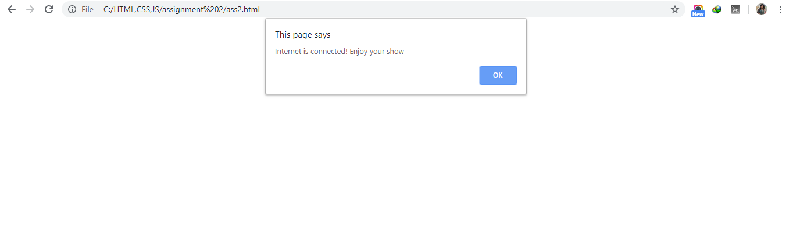

1. Internet Disconnected

